### Dayalbagh Educational Institute



*A Project report on Image Enhancement submitted in partial fulfillment of the requirements for*

*the award of the degree of*

**MASTER OF SCIENCE**

**IN**

**COMPUTER SCIENCE**

***Submitted by:***

***Rishi Raj Sharma (2402519)  
Mohit Kumar (2402515)***

**Under the Supervision of**

### Objective

The primary objective of image enhancement is to improve the quality of an image by making it more suitable for human perception. This can be done by enhancing specific features such as contrast, brightness, sharpness, or reducing noise to make important details more visible. Image enhancement can be applied to a wide variety of fields including medical imaging, remote sensing, forensics, and entertainment.

Some of the core objectives are:

1. **Improve Visual Quality:**  
   Image must be visually clearer or more appealing to the human eye. This could involve adjustments like enhancing contrast or brightness of it.
2. **Enhance Specific Features:**  
   Nowadays Image enhancement techniques focus on amplifying particular features, such as edges, or textures. This is important for such applications like satellite imaging, where identifying specific features of interest (such as roads or buildings) is important.
3. **Noise Reduction:**  
   It is often necessary to clean up an image and remove irrelevant artifacts. Techniques such as sharpness and filtering help reduce noise and make the image more eye pleasing for further analysis or machine learning tasks.
4. **Prepare for Further Processing:**  
   Image enhancement is often a pre-processing and post-clicking step to make the image more suitable for subsequent computer vision tasks, such as segmentation. Enhancing key aspects of the image helps improve the accuracy of algorithms in interpreting visual data.
5. **Aid in Feature Extraction:**  
   Image enhancement is intended to make it easier to extract features from the image, such as facial features in surveillance videos or organs in medical images. Enhancing these features can improve the performance of models in pattern recognition tasks.
6. **Optimize Image for Specific Applications:**  
   Different applications may require different types of enhancement, for instance, like in criminal investigations or medical diagnostics, or optimizing images for real-time applications like video streaming or surveillance.

Overall, the ultimate goal of image enhancement is to enhance the image's utility for its intended application, whether for improving aesthetic appeal or for processing tasks such as feature extraction, recognition, or analysis.

1. **Acknowledgement**

We would like to express our gratitude to those who has supported us throughout the preparation of this project on **Image Enhancement**. First of all, we would like to extend our heartfelt thanks to our project supervisor for their guidance, encouragement, and valuable insights, which have been instrumental in completing this work successfully.

We would also like to acknowledge the collaborative effort between us and my friend, whose continuous support, shared ideas, and dedication played a key role in shaping the project. This teamwork helped us tackle challenges and improve our approach.

Furthermore, we are grateful for the vast array of open-source tools like (Python, OpenCV and NumPY and many more also) and resources that made our project feasible, especially **OpenCV**, **TensorFlow**, which have provided us with the necessary functionality for implementing image enhancement techniques.

We would like to thank the authors of the numerous research papers, books, and online articles whose work provided crucial knowledge and a strong theoretical foundation for this project. Their contributions to the field of image enhancement have shaped our understanding and approach.

1. **Introduction**

Image Enhancement is a process of improving the quality, clarity, and visual interpretation of digital images.

Image enhancement refers to the process of improving the visual appearance of an image or making it more suitable for analysis by enhancing certain features or qualities of the image. This process involves various techniques to highlight important details, correct distortions, adjust brightness and contrast, remove noise, and sharpen the image.

Key Techniques:

1. **Histogram Equalization**: Adjusts the contrast of an image by redistributing the intensity values.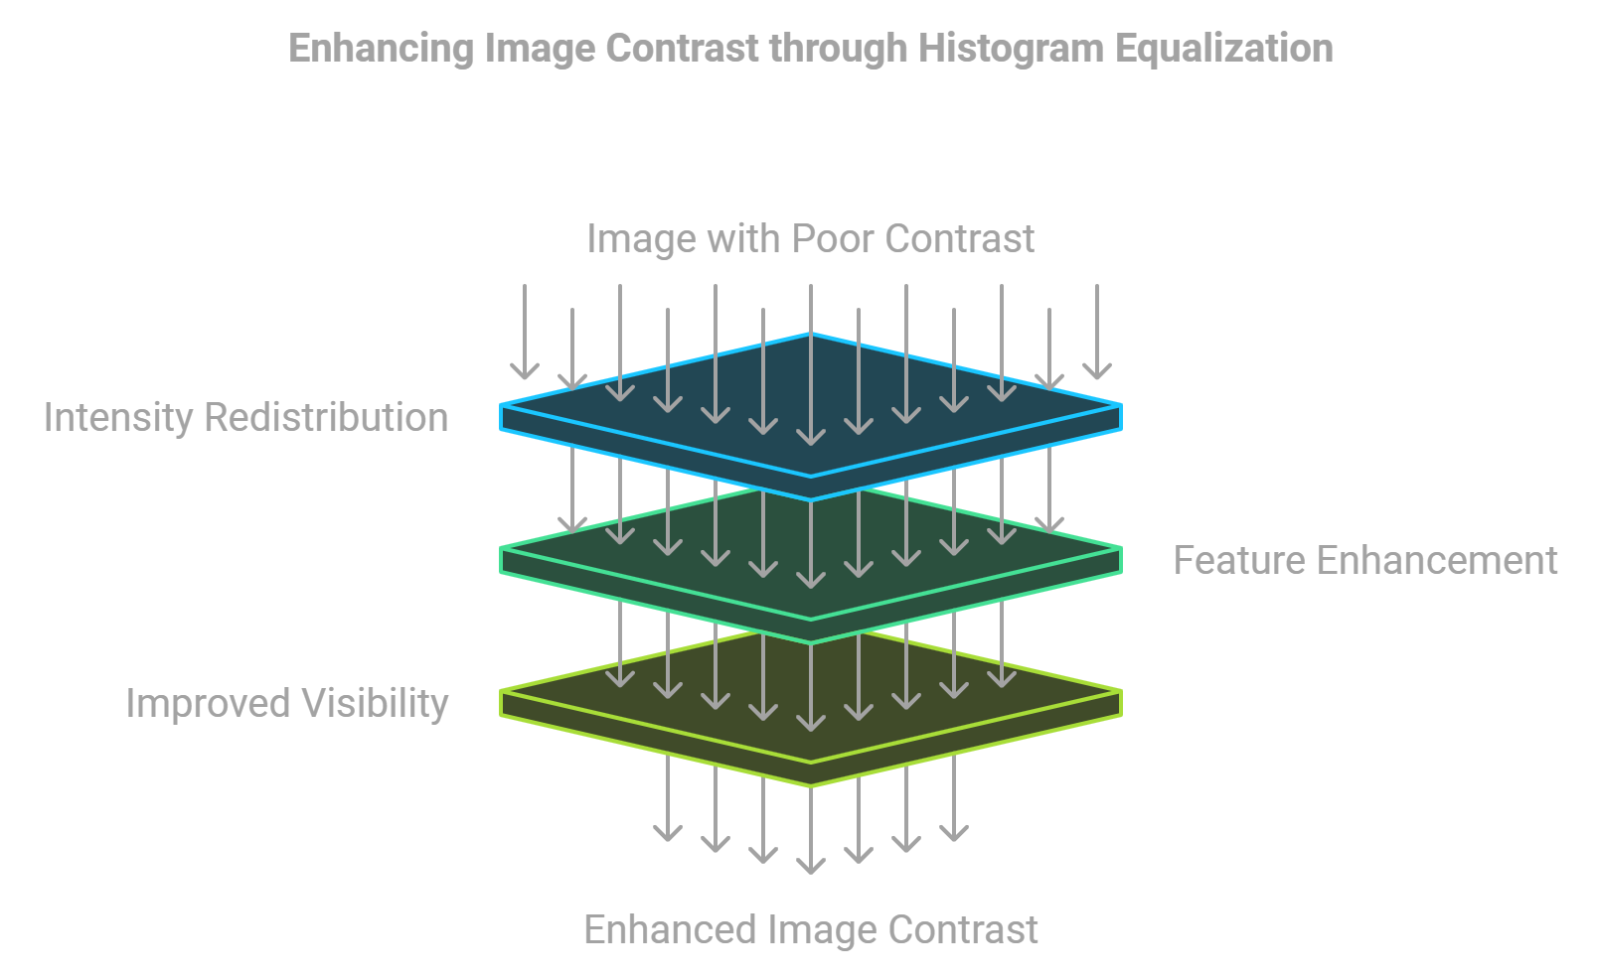

2. **Noise Reduction**: Reduces random variations in brightness, which can be achieved using filters like Gaussian, Median, or Wiener filters.  
  
  
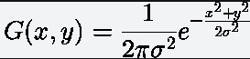  
Where,x → X coordinate valuey → Y coordinate valueπ → Mathematical Constant PI (value = 3.13)σ → Standard Deviation

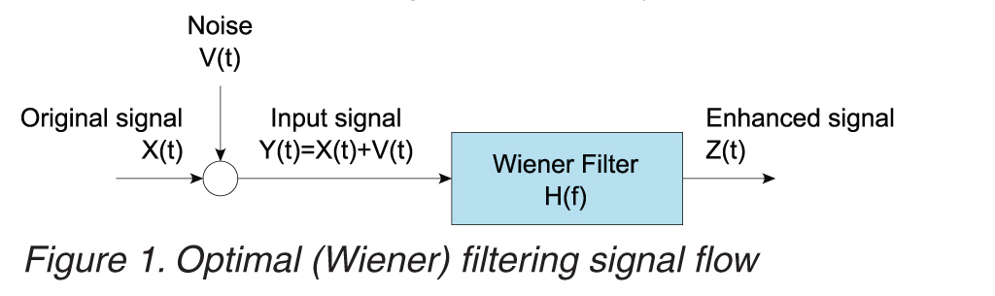

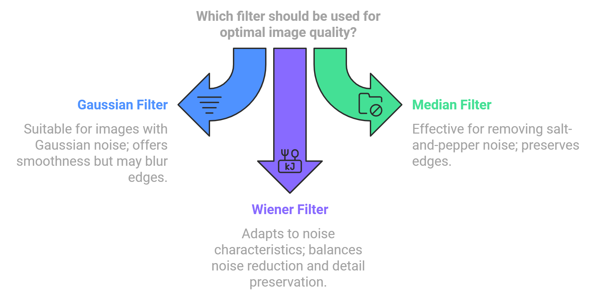

3. **Sharpening**: Enhances edges and fine details in an image, often using techniques like unsharp masking or high-pass filtering.   
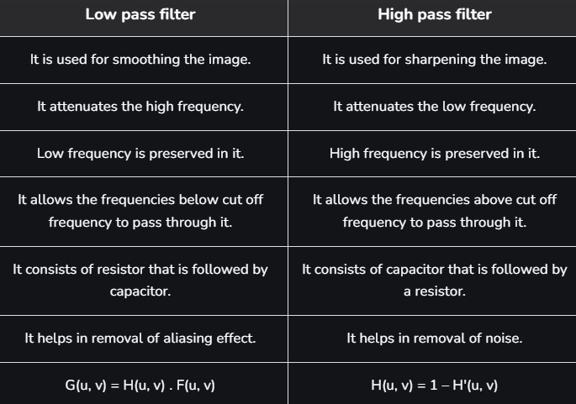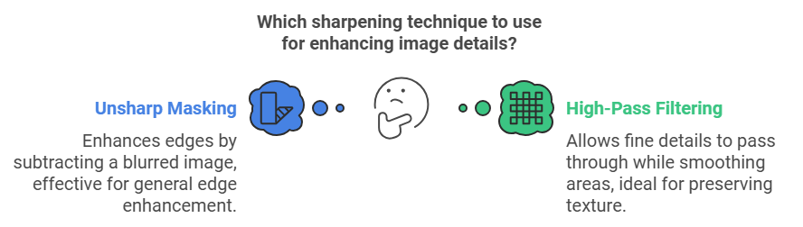

4. **Brightness and Contrast Adjustment**: Modifies the overall lightness and contrast levels to make details more visible. 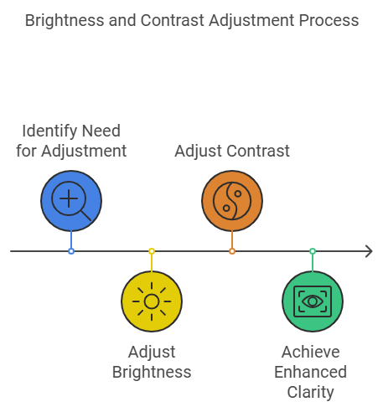

5. **Smoothing**: Blurs the image slightly to reduce detail and noise, useful for preparing the image for further processing. 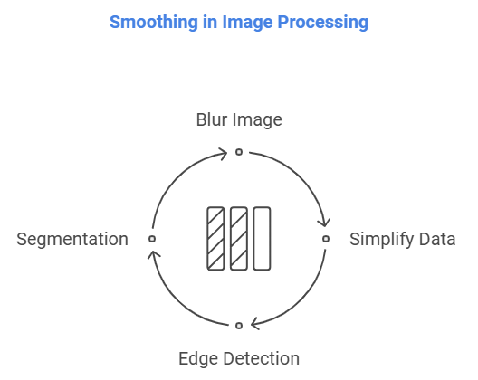

Image enhancement can be crucial in various fields such as medical imaging, satellite imagery, and photography, enabling better visualization and interpretation of images.

1. **Purpose**

Improve image visibility, extract more information, and make visual details more interpretable.

The purpose of **image enhancement** is to improve the visual appearance of an image or to transform it in a way that better suits specific applications. This process is crucial in various fields to make images clearer, more interpretable, and valuable for analysis. Here are the primary objectives:

**1. Improve Visual Quality**

* **Objective**: Enhance the image's contrast, sharpness, or color to make it visually appealing.
* **Application**: Used in photography, cinematography, and digital art to refine raw images for presentation.

**2. Enhance Interpretability**

* **Objective**: Highlight important details or features in an image that are otherwise not visible.
* **Application**: Vital in medical imaging (e.g., MRI or X-ray scans) to detect anomalies and assist in diagnoses.

**3. Prepare Images for Analysis**

* **Objective**: Facilitate better performance in computer vision algorithms by improving input image quality.
* **Application**: Used in object detection, facial recognition, and machine learning models.

**4. Restore Degraded Images**

* **Objective**: Reconstruct images degraded due to noise, blurring, or low resolution.
* **Application**: Critical in surveillance (low-light footage) and satellite imaging (cloudy or atmospheric interference).

**5. Adapt Images for Specific Applications**

* **Objective**: Customize images for tasks like printing, display on screens, or embedding in devices.
* **Application**: Optimization for varied hardware such as printers, monitors, or mobile devices.

**6. Highlight Specific Features**

* **Objective**: Extract or emphasize certain details, such as edges, contours, or textures, for better understanding.
* **Application**: Geographical and scientific imaging, where specific terrain or material properties need focus.

**Summary**

Image enhancement enables better visual perception, improved analysis, and restoration of degraded information, supporting fields like healthcare, security, digital art, remote sensing, and AI-driven systems. It bridges the gap between raw data and actionable insights, making it a cornerstone of image processing technology. 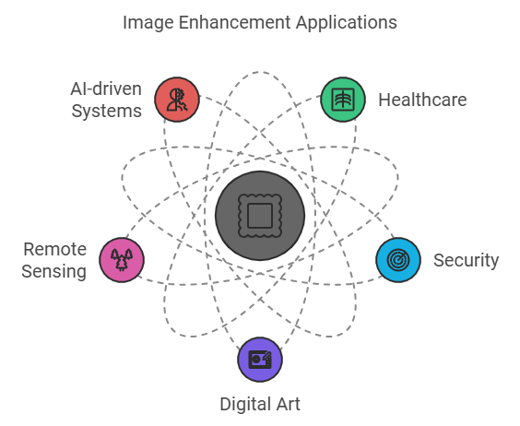

1. **Primary Techniques**

The **primary techniques of image enhancement** are broadly categorized into spatial domain methods and frequency domain methods. These techniques are used to improve the visual quality and usability of images for various applications.

### ****1. Spatial Domain Techniques****

These methods directly manipulate pixel values to enhance an image.

#### **1.1. Point Processing**

* Adjust pixel intensities to enhance overall brightness, contrast, or color balance.
  + **Techniques**:
    - **Histogram Equalization**: Spreads out intensity values to enhance contrast.
    - **Logarithmic Transformations**: Expands dark regions while compressing bright ones.
    - **Power-Law (Gamma) Transformations**: Controls brightness and contrast using gamma correction.

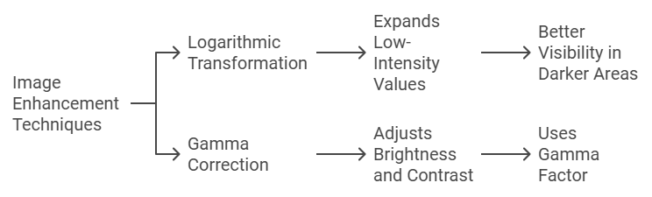

#### **1.2. Spatial Filtering**

* Uses convolution masks to process an image.
  + **Techniques**:
    - **Smoothing Filters**:
      * **Mean Filter**: Reduces noise by averaging pixel values.
      * **Gaussian Filter**: Smoothens an image while retaining edges.
    - **Sharpening Filters**:
      * **Laplacian Filter**: Enhances edges by emphasizing intensity changes.
      * **Unsharp Masking**: Combines a blurred version with the original image to highlight details.

#### **1.3. Region-Based Processing**

* Enhances specific regions of an image based on criteria like brightness or shape.
  + **Example**: Adaptive histogram equalization for localized contrast improvement.

### ****2. Frequency Domain Techniques****

These methods work by transforming the image into the frequency domain and manipulating its spectral components.

#### **2.1. Fourier Transform**

* Converts an image from the spatial domain to the frequency domain.
  + **Techniques**:
    - **Low-Pass Filtering**: Reduces high-frequency noise, resulting in a smoother image.
    - **High-Pass Filtering**: Preserves high-frequency details, enhancing edges and fine details.

#### **2.2. Wavelet Transform**

* Decomposes an image into multiple scales or resolutions for enhancement.
  + **Applications**: Used in denoising and texture enhancement.

#### **2.3. Homomorphic Filtering**

* Separates illumination (low-frequency) and reflectance (high-frequency) components.
  + **Purpose**: Enhances details by suppressing illumination variations.

### ****3. Advanced Techniques****

These techniques often involve machine learning or specialized algorithms.

#### **3.1. Adaptive Enhancement**

* Modifies enhancement parameters dynamically based on the image content.
  + **Example**: Adaptive histogram equalization for better local contrast. 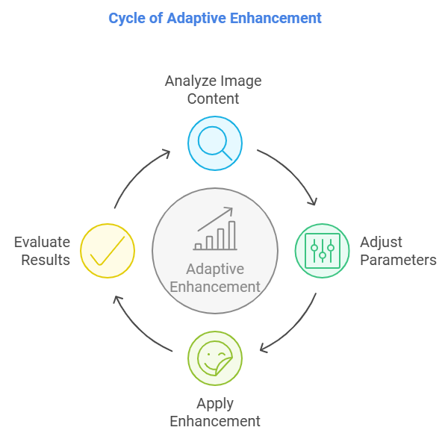

#### **3.2. Super-Resolution**

* Reconstructs high-resolution images from low-resolution inputs using techniques like bicubic interpolation or neural networks.

#### **3.3. Noise Reduction**

* Suppresses noise while preserving important details.
  + **Techniques**:
    - Median Filtering.
    - AI-based denoising (e.g., using deep learning models).

#### **3.4. Deep Learning Methods**

* Utilize neural networks like GANs or autoencoders for tasks like colorization, upscaling, or restoration.

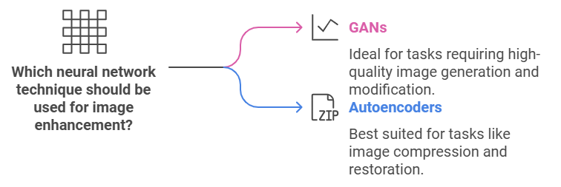

### Summary

Each technique is chosen based on the type of enhancement required, whether it's improving contrast, reducing noise, sharpening edges, or removing blur. Advances in machine learning have further expanded the capabilities of traditional image enhancement techniques, making them faster and more effective for real-world applications.

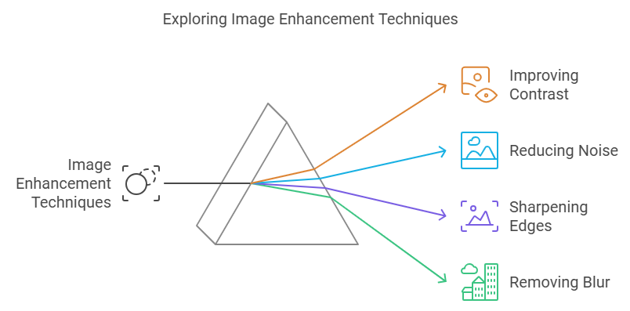

1. **Methods**

**Methods of Image Enhancement** involve various techniques to improve image quality by enhancing its visual attributes or preparing it for specific applications. These methods are primarily divided into two categories: spatial domain methods and frequency domain methods. Here's an overview of the most common techniques:

### ****1. Spatial Domain Methods****

In spatial domain methods, image pixel values are directly manipulated to enhance quality.

#### **1.1. Histogram-Based Techniques**

* **Histogram Equalization (HE)**: Redistributes pixel intensity values to improve contrast.
* **Adaptive Histogram Equalization (AHE)**: Enhances contrast in localized regions for better details in unevenly lit areas.

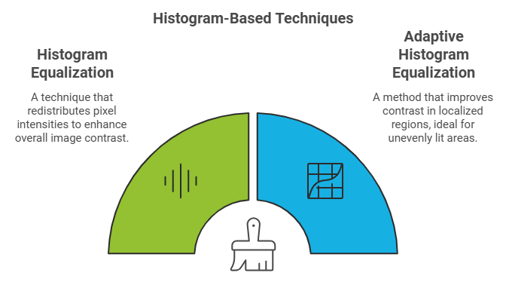

#### **1.2. Point Processing**

* **Logarithmic Transformation**: Expands low-intensity values for better visibility in darker areas.
* **Gamma Correction**: Adjusts brightness and contrast using a gamma factor.

#### **1.3. Filtering Techniques**

* **Smoothing Filters**: Reduce noise and smooth out details.
  + Examples: Mean filter, Gaussian filter.
* **Sharpening Filters**: Highlight edges and fine details.
  + Examples: Laplacian filter, Sobel operator.

#### **1.4. Morphological Operations**

* Enhance shapes and edges based on structural elements.
  + Examples: Dilation, erosion, opening, and closing.

### ****2. Frequency Domain Methods****

These methods involve transforming the image into the frequency domain to operate on its spectral components.

#### **2.1. Fourier Transform**

* Converts an image to its frequency representation to apply filtering techniques.
  + **Low-Pass Filter**: Removes high-frequency noise, making the image smoother.
  + **High-Pass Filter**: Enhances edges and fine details by amplifying high frequencies.

#### **2.2. Wavelet Transform**

* Decomposes images into multiple scales or resolutions for targeted enhancement.
  + Used in texture enhancement, noise reduction, and super-resolution.

#### **2.3. Homomorphic Filtering**

* Separates illumination (low-frequency) and reflectance (high-frequency) components.
  + Enhances details and corrects uneven lighting.

### ****3. Machine Learning and Deep Learning Methods****

Advancements in AI have led to the adoption of intelligent image enhancement techniques.

#### **3.1. Super-Resolution Techniques**

* AI models reconstruct high-resolution images from low-resolution inputs.
  + Examples: GAN-based super-resolution, ESRGAN.

#### **3.2. Denoising Autoencoders**

* Neural networks trained to reduce noise while preserving image details.

#### **3.3. Colorization**

* Neural networks restore or add colors to grayscale images.

#### **3.4. Style Transfer**

* AI models enhance images by applying artistic or visual styles.

### ****4. Hybrid and Adaptive Methods****

These methods combine multiple techniques for improved results.

#### **4.1. Adaptive Enhancement**

* Dynamically adjusts enhancement parameters based on local image characteristics.
  + Example: Contrast Limited Adaptive Histogram Equalization (CLAHE).

#### **4.2. Multi-Scale Retinex (MSR)**

* Mimics the human visual system to enhance images under poor lighting conditions.
* 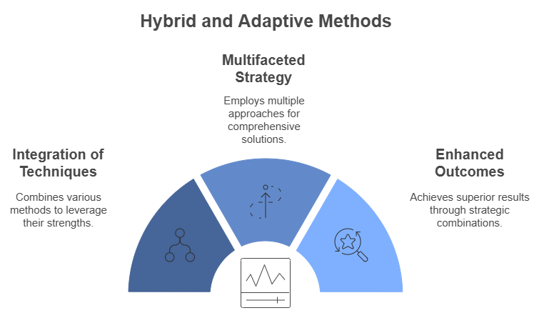

### ****Applications****

* **Medical imaging**: Enhances X-rays, MRIs, and CT scans for better diagnosis.
* **Surveillance**: Improves visibility in low-light or hazy conditions.
* **Remote sensing**: Enhances satellite (Satellite and aerial photography) imagery for better interpretation.
* **Photography** (Digital photography): Enhances colors, sharpness, and contrast.
* **Forensic Analysis**: Forensic image analysis uses **image enhancement** techniques to extract, clarify, and analyze visual information from images that might otherwise be too distorted, unclear, or corrupted to use effectively. This is particularly crucial in fields like criminal investigations, digital forensics, and legal proceedings.
* **Machine vision and image recognition**: Machine vision refers to the technology and processes that allow machines to analyze visual inputs for specific applications, such as inspection, measurement, and automation. Image enhancement supports this by improving the quality and clarity of the images fed into the machine vision systems.

**Summary**Image enhancement plays a pivotal role across diverse applications by improving image quality for better interpretation and usability. In **medical imaging**, it sharpens X-rays, MRIs, and CT scans to aid accurate diagnoses. In **surveillance**, enhancement techniques improve visibility in low-light or hazy conditions, crucial for security and monitoring. For **remote sensing**, it refines satellite and aerial imagery, enabling better environmental and geographical analysis. In **digital photography**, it adjusts colors, contrast, and sharpness to produce visually appealing photos.

In **forensic analysis**, enhancement clarifies distorted or unclear images, providing critical visual evidence for criminal investigations, digital forensics, and legal proceedings. For **machine vision and image recognition**, it improves the clarity of images fed into automated systems, facilitating applications like industrial inspection, measurement, and robotics. These applications demonstrate the transformative power of image enhancement across healthcare, security, environmental studies, and technology-driven fields. 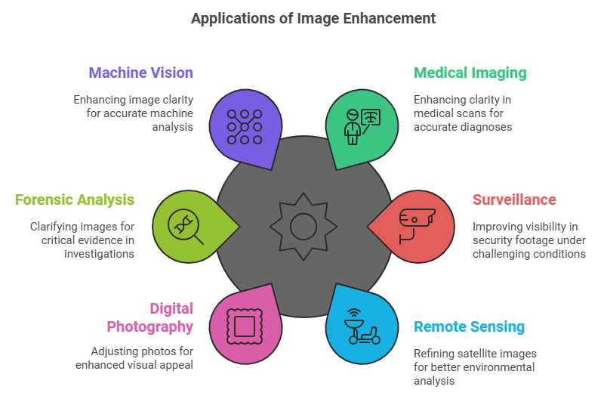

1. **Goals**:

- **Highlight important image features:** Image enhancement techniques aim to bring out specific details such as edges, textures, and regions of interest within an image. This is crucial in applications like medical imaging (highlighting tumors), remote sensing (identifying land features), or forensic analysis (enhancing evidence). Common methods include edge detection, sharpening filters, and feature extraction algorithms

- **Reduce visual artifacts:** Images often contain unwanted artifacts such as noise, blur, or compression artifacts that degrade quality. Enhancement processes, such as noise reduction (using median or Gaussian filters) and deblurring algorithms, improve the visual integrity of images. These are vital in areas like surveillance, where poor-quality footage needs enhancement for analysis.

**- Improve perceptual quality:** Perceptual quality enhancement ensures that images appear visually appealing or easier to interpret. Techniques like contrast adjustment, brightness normalization, and color correction enhance the clarity and richness of images, making them suitable for use in digital media, presentations, or artistic applications.

**- Prepare images for further analysis or processing:** Enhanced images serve as better inputs for downstream applications like machine vision, AI-based recognition, and feature analysis. Preprocessing steps like histogram equalization, noise suppression, and resolution enhancement optimize images for accurate segmentation, classification, or object detection.

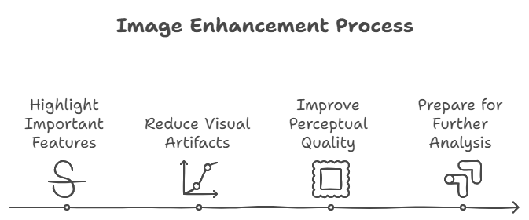

**Summary**Image enhancement techniques aim to improve the quality and usability of images by highlighting important features like edges and textures, which is essential in applications such as medical imaging, forensic analysis, and remote sensing. They also reduce visual artifacts, such as noise and blurriness, through methods like noise reduction and deblurring, ensuring clearer and more accurate images. Additionally, enhancement processes improve perceptual quality by adjusting contrast, brightness, and color, making images more visually appealing and easier to interpret. Ultimately, these techniques prepare images for further analysis or processing, optimizing them for tasks like machine learning, segmentation, and object detection, thereby making them more effective for automated and analytical applications across various fields.

1. **Key Considerations**

**- Maintaining original image information:** In image enhancement, it's crucial to preserve the essential information in the original image while improving its quality. Over-enhancement or incorrect adjustments could distort the original features, leading to misinterpretation. Techniques like contrast enhancement or sharpening should carefully maintain key details, such as edges and textures, which are vital for analysis. Preserving the integrity of the original content ensures that the enhanced image still reflects true representations of the scene, especially for critical applications like medical imaging and forensic analysis.

**- Avoiding over-processing:** Over-processing occurs when excessive enhancements lead to unwanted artifacts or distortions, making the image less realistic or harder to interpret. For example, sharpening an image too much can introduce noise or halo effects, making it visually unappealing or difficult to analyze. To avoid this, it's essential to apply enhancement techniques judiciously, ensuring that the changes improve the image's quality without introducing errors or reducing the image's accuracy. The goal is to enhance, not alter, the underlying data.

**- Balancing visual enhancement with computational complexity:** Enhancement algorithms, especially those applied to large datasets (e.g., satellite images), often require significant computational resources. While enhancing an image, it's important to balance the visual improvements with the computational effort. Some complex methods might produce high-quality results but are computationally expensive, which may not be practical in real-time systems or with limited hardware. Thus, an optimal enhancement approach should achieve desired visual results while maintaining feasible computational requirements, ensuring efficiency without compromising quality.

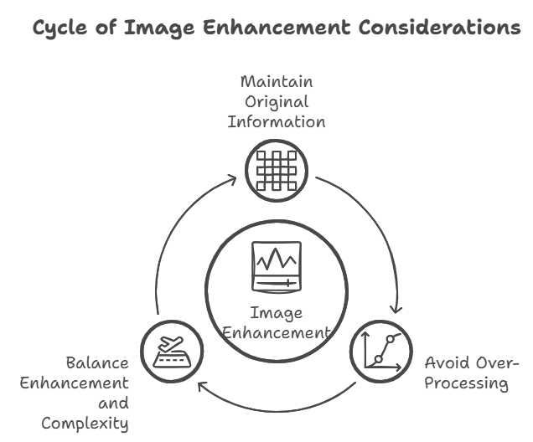

**Summary**

In image enhancement, it is crucial to **maintain the original image information** to preserve essential features like edges and textures, ensuring that the enhanced image accurately reflects the true scene. **Avoiding over-processing** is key to preventing artifacts or distortions, which can reduce the image’s quality or make it harder to interpret. Enhancement techniques should be applied carefully to improve visual appeal without altering the core data. Additionally, **balancing visual enhancement with computational complexity** is essential, as some techniques may improve image quality but require significant computational resources. The goal is to achieve effective enhancement while maintaining computational efficiency, making sure the improvements are practical and suitable for real-time or resource-constrained applications.

1. **Tools and Software Used**To include the tools or software used in your project report, you can create a section that briefly lists and describes each tool, software, or library utilized in your project. Below is an example of how you can format and present this information in your **"Tools and Software"** section:

### Tools and Software Used

In the completion of this Image Enhancement project, the following tools and software were utilized:

1. **Python Programming Language**  
   Python was the primary language used for implementing the image enhancement techniques due to its ease of use and extensive libraries for image processing, machine learning, and data analysis.
2. **OpenCV (Open Source Computer Vision Library)**  
   OpenCV was used for image processing tasks, including applying filters, adjusting contrast, and performing image manipulations. OpenCV's robust set of functions made it possible to implement complex image enhancement operations efficiently.
3. **TensorFlow**  
   TensorFlow, an open-source deep learning library developed by Google, was used to implement machine learning models for image enhancement. We leveraged pre-trained models and fine-tuned them for specific tasks such as noise reduction and image restoration.
4. **Pillow (PIL Fork)**  
   Pillow, a Python Imaging Library, was used for simple image operations like loading, saving, and resizing images. It also helped with enhancing image brightness and sharpness.
5. **Matplotlib**  
   Matplotlib was used for visualizing the images before and after enhancement. It helped in generating plots and displaying results for performance comparison of different enhancement techniques.
6. **NumPy**  
   NumPy was used for handling multi-dimensional arrays and performing mathematical operations on images, such as pixel-wise adjustments and applying transformations.

These tools and libraries enabled efficient implementation of various image enhancement techniques and provided the flexibility to experiment with different approaches. They are widely used in the image processing and machine learning community, ensuring that the project follows industry standards.

1. **References:**

* **Gonzalez, R. C., & Woods, R. E. (2018). *Digital Image Processing* (4th ed.). Pearson Education. This book discusses the application of advanced algorithms in image processing, including AI and machine learning techniques that are increasingly used in image enhancement.**
* **Zhang, L., Zhang, L., & Yang, M. H. (2020). *Deep Learning for Image Enhancement*. In IEEE Transactions on Pattern Analysis and Machine Intelligence. This paper explores the use of deep learning models for real-time image enhancement and its applications in various fields like medical imaging and video surveillance.**
* **Li, Z. (2018). *Real-time Video Enhancement Techniques*. In Journal of Real-time Imaging. The article covers advancements in real-time image and video enhancement, discussing the challenges and solutions for improving video streaming and security footage.**
* **Zhang, K., et al. (2021). *Adaptive Image Enhancement for Digital Photography*. In International Journal of Computer Vision. This research discusses the development of adaptive algorithms for enhancing images based on their content and user preferences.**
* **Chen, Z., Huang, X., & Xie, L. (2021). *Cross-platform Optimization in Image Enhancement*. In IEEE Access. This paper emphasizes the importance of enhancing image processing methods for cross-platform compatibility, improving consistency in quality across different devices.**
* [**Low Pass Filtering and High Pass Filtering**](https://www.geeksforgeeks.org/difference-between-low-pass-filter-and-high-pass-filter/)
* [**Restoration-filters**](https://www.geeksforgeeks.org/types-of-restoration-filters/)
* [**Gauss-filter-to-an-image**](https://www.geeksforgeeks.org/apply-a-gauss-filter-to-an-image-with-python/)
* Ana Belén Petro, Catalina Sbert, and Jean-Michel Morel, *Multiscale Retinex*, [Image Processing On Line](https://doi.org/10.5201/ipol),  (2014), pp. 71–88.
* [**Denoising-autoencoders**](https://towardsdatascience.com/denoising-autoencoders-explained-dbb82467fc2)

**The Codes which I have used used to perform the Image Enhancement:**

*import cv2 as cv                                        #importing the open cv library for image processing*

*import numpy as np                                      #importing the numpy library as np to create kernel matrix*

*from matplotlib import pyplot as plt                    #importing the plotting library to plot histogram*

*file_location = input('Enter image location : ')*

*img = cv.imread(file_location)           #reading image using imread function in cv2*

*img = cv.resize(img, (640,480))                         #resizing the image so that it is easier to perform operations on it*

*cv.imshow('img', img)                                   #displaying the original image read and stored in img variable*

*kernel_1 = np.ones((3,3))                               #creating a matrix of 3 by 3 having all elements as 1*

*for i in range(len(kernel_1)):                          #looping throughout the rows*

*for j in range(len(kernel_1)):                      #looping in the columns*

*kernel_1[i][j]=-1                               #changing all elements to -1*

*m=len(kernel_1)//2                                      #taking the mid of list and assigning it to m*

*kernel_1[m][m]=9                                        #changing the central element to 9 to form the final kernel matrix that will be used to sharpen the image*

*img1 = cv.filter2D(img, -1, kernel_1)                   #using the filter2D function to sharpen the blurred input image to make it a bit clear*

*# cv.imshow('img_filter2D_sharp', img1)                   #this displays the sharpened image after add weighting the original image*

*gauss = cv.GaussianBlur(img, (9,9), 0,)                 #defining Gaussianblur along with a 9X9 kernel to perform add weighted function for image sharpening*

*img2 = cv.addWeighted(img, 1.5, gauss, -0.5, 3)         #this takes the original image and the gaussian blurred image adds weight to sharpen the image*

*# cv.imshow('img_addweight_sharp', img2)                  #this displays the sharpened image after add weighting the original image*

*img = cv.addWeighted(img1, 0.4, img2, 0.6, 0)           #here we are sharpening the image using the addweighted filter taking gaussian blurred and original image as input in 0.6 and 0.4 ratio to combine them to make the final sharpened image*

*# cv.imshow('img_final_sharp', img)                       #displaying the final sharpened image*

*img = cv.cvtColor(img, cv.COLOR_BGR2HSV)                #this convertes the sharpened image i.e. from BGR format into HSV format to split the image into 3 layers of Hue, Saturation and Value*

*h,s,v = cv.split(img)                                   #splitting the image into Hue, Saturation and Value*

*hist = cv.calcHist([v], [0], None, [256], [0,155])      #this function calculates the intensity of image and number of pixels having that intensity*

*plt.plot(hist)                                          #this function plots the histogram of intensity of brightness vs the frequency of pixels having that frequency*

*v = cv.equalizeHist(v)                                  #here we are optimizing the brightness and contrast of the image*

*hist = cv.calcHist([v], [0], None, [256], [0,256])      #this function calculates the intensity of image and number of pixels having that intensity*

*plt.plot(hist)                                          #this function plots the histogram of intensity of brightness vs the frequency of pixels having that frequency*

*img_merge = cv.merge((h, s, v))                         #after optimizing the image brightness and contrast we are merging the layers of the image that we have splitted before*

*img_eq = cv.cvtColor(img_merge, cv.COLOR_HSV2BGR)       #after merging the layers convert the image from HSV to BGR again*

*cv.imshow('img_eq', img_eq)                           #after optimizing the image we are showing the optimized image in the img_eq window*

*# plt.show()                                              #plotting all the histograms*

*cv.waitKey(0)                                           #after displaying the image wait for this much time(in miliseconds) here 0 represents infinte time*

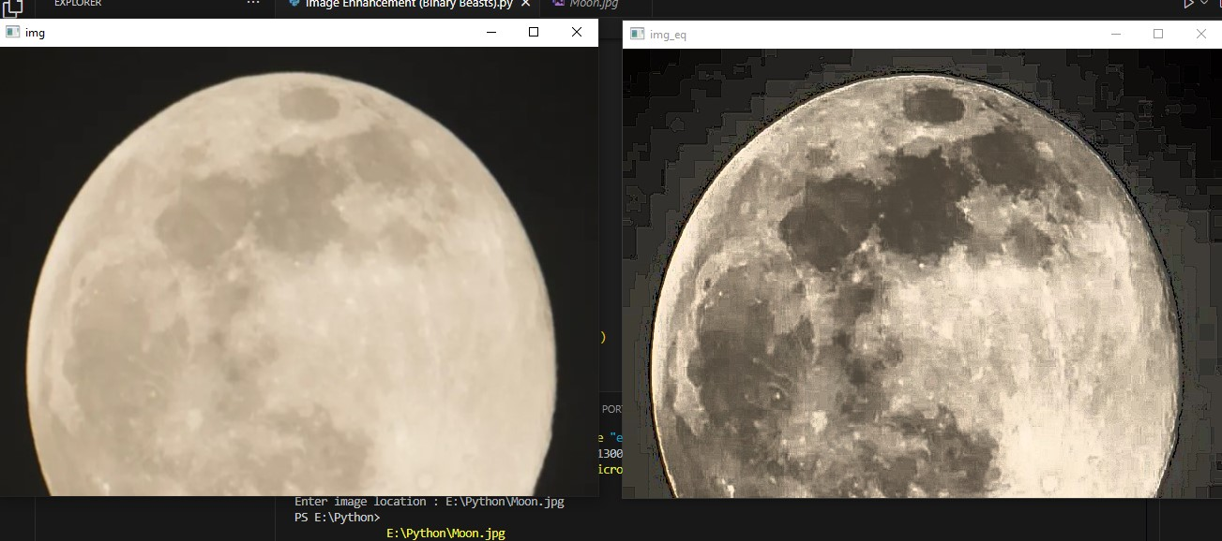

Here this is the example I have taken raw picture from Internet and after the Enhancement, You can see the difference from the basic and Enhanced Image…